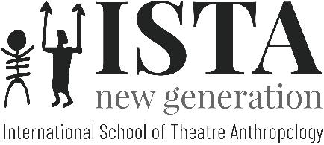

APPLICATION FORM 17th ISTA/NG

INTERNATIONAL SCHOOL OF THEATRE ANTHROPOLOGY / NEW GENERATION
directed by Eugenio Barba

Pécsvárad-Budapest (Hungary), 7-21 May 2023

PRE-ESPREXIVITY - COMPOSITION - MONTAGE

First Name:
Family Name:
Sex:
Age:
Email:
Mobile/Cell Phone:
Nationality:
Spoken Languages:
Are you vegan or vegetarian?
Do you have any allergies, which we should be aware of (e.g. food allergies)?
Education:
Profession:
What is your motivation for wishing to participate?
Have you previously participated in an Odin Teatret seminar or ISTA session?

